**Ecosystem Genomics Seminar Series (Fall 2018)**

Thursdays, 4:00-5:00 pm in BIO5 area

Keating Bioresearch Building & Medical Research Building

|  |  |  |  |
| --- | --- | --- | --- |
| **Thursday** | **Location** | **Speaker** | **Title** |
| August  30 | Keating 103 | Scott Saleska,  UA EEB | The promise of ecosystem genomics for advancing our understanding of earth system processes: Four challenges |
| September 6 | Keating 103 | Malak Tfaily  UA SWES | TBD |
| September 13 | Keating 103 | Bonnie Hurwitz  UA ABE | TBD |
| September 20 | Keating 103 | Rod Wing  UA Plant Sciences | TBD |
| September 27 | Keating 103 | TBD | TBD |
| October  4 | Keating 103 | Rachel Gallery  UA SNRE | TBD |
| October 11 | MRB  102 | TBD | TBD |
| October 18 | Keating 103 | Laura Meredith,  UA SNRE | TBD |
| October 25 | MRB  102 | TBD | TBD |
| November 1 | Keating 103 | Jana U'Ren  UA ABE | TBD |
| November 8 | Keating 247* | Betul Kacar  UA MCB | *Professional Development* |
| November 15 | Keating 103 | Russ Monson  UA Tree Ring Lab | TBD |
| November 20, **Tues\*** | MRB  102 | Duke Pauli  UA Plant Sciences | TBD |
| November 29 | Keating 103 | Regis Ferriere  UA EEB | TBD |
| December 6 | - | No seminar (reading day) |  |
| December 13 | Keating 103 | Brendan Bohannan  U Oregon | TBD |

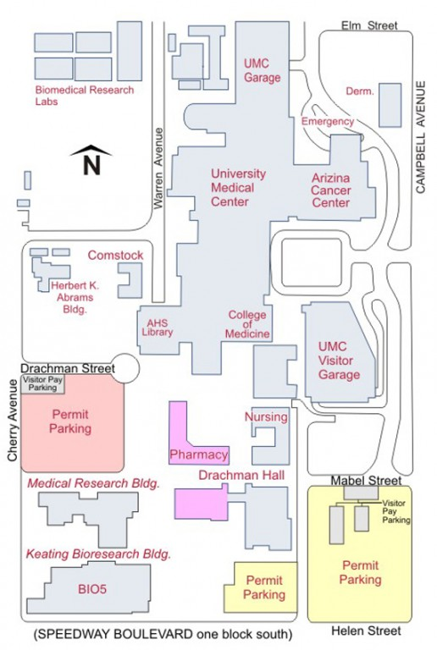**Seminar series is open to all!!**  
Social hour to follow each seminar.

